LAB 4. ACID BASE TITRATION

An acid–base titration represents a controlled addition of a base of known concentration to an acid of unknown concentration (or vice-versa). The goal of the titration is to determine the unknown concentration of the acid.

Equipment
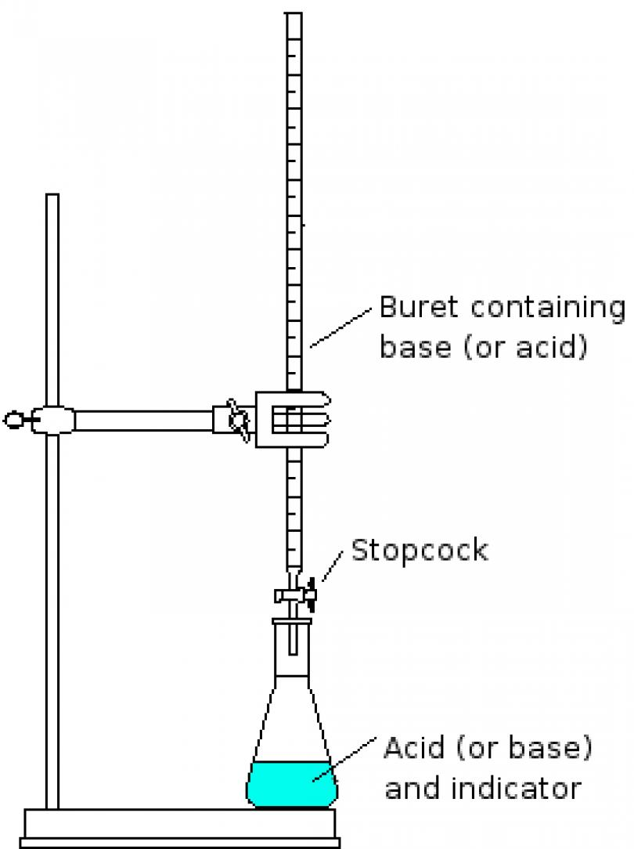

Burette – filled with the base of known concentration

Erlenmayer flask – containing the acid of unknown concentration and an indicator

Indicator – a chemical substance that changes color near the equivalence point. The point at which the indicator changes color and the titration is stopped is called the endpoint. Ideally, the endpoint should coincide with the equivalence point

Equivalence point – is the point when the amount of base added from the burette is exactly the amount needed to react completely with the acid from the flask.

The titration is performed by slowly dripping the basic solution from the burette into a flask containing a measured amount of the acidic solution and several drops of a chemical indicator, under continuous shaking. The titration is stopped when the indicator changes its color.

The reaction between an acid and a base is called a neutralization reaction.

HCl + NaOH → NaCl + H₂O

H₃PO₄ + 3 NaOH → Na₃PO₄ + 3 H₂O

Example: 30 mL of NaOH solution of unknown concentration was titrated with 2.0 M HCl in the burette. The following data was obtained:
Initial reading of burette = 0
Final reading of burette = 22.5 mL
What is the molarity of NaOH solution? (A: 1.5 M)

Example: 25.0 mL of 0.05 M barium hydroxide Ba(OH)₂ neutralized 40.0 mL of nitric acid. Determine the concentration of the acid. (A: 0.0625 M)

Procedure

1. Prepare 250 mL of 0.1 M NaOH solution. Use a spatula and a watch glass to weight the amount of NaOH needed to prepare the solution. Use a volumetric flask to prepare the solution.

2. Use a funnel to fill the burette with NaOH solution, so that the meniscus is a little above the zero mark. Be sure to let any bubbles out of the tip of the burette. Adjust the level on NaOH in the burette to exactly zero.

3. Use a pipette to measure 5 mL of sulfuric acid solution and add it in the Erlenmeyer flask.

4. Add 2-3 drops of phenolphthalein to the flask and start titration. Add the NaOH solution dropwise, swirling the flask constantly. Before the endpoint is reached, a temporary pink color will be seen where the NaOH drop hits the bulk solution. Stop as soon as the first permanent pale pink color appears. This is the endpoint. Read the burette indication and record the reading.

5. Calculate the molarity of the H₂SO₄ solution.

SAFETY WARNING

Sodium hydroxide is extremely basic, caustic, and corrosive. Use of rubber gloves and safety glasses when preparing NaOH solution is recommended. NEVER pour a solution of NaOH or any other caustic substance above eye level. Place the burette stand on the floor to fill your burette. If you get any of the solution on your hands or clothes, rinse it off immediately with large amounts of water. Keep your hands away from your eyes at all times during the experiment unless you have just rinsed your hands thoroughly. Sodium hydroxide solutions feel slimy or slippery to the touch. If your fingers ever feel extra slippery or if some part of your body starts itching wash the affected part with lots of water immediately.

QUESTIONS
- What is the goal of the titration?
- What is the indicator? What happens with the indicator near the equivalence point?
- What is the equivalence point in a titration?

